Fisheries Paper

**Executive Summary**

**Introduction**

In 2023 Scotland’s fleet had more power and capacity than any other region in the UK. They have also been known to target higher quantities of lower priced species, which results in them having larger vessels with greater carrying capacities. Their fleets also land the highest quantity and value of fleets from other regions in the UK.

**Methods**

Data Collection

Data

Value of catch is reported as the value at the time of the transaction, with no adjustments made to account for changes in inflation. Therefore, we used the Consumer Price Index (CPI) to convert historical prices to most recent prices in the data (2023).

Data Handling and Analysis

**Results**

Landings in the UK from UK Vessels

**Figure 1.** Value of landings by species for UK vessels into the UK from 2014 - 2023. The value of landings has been converted to equivalent prices in 2023 using the CPI.

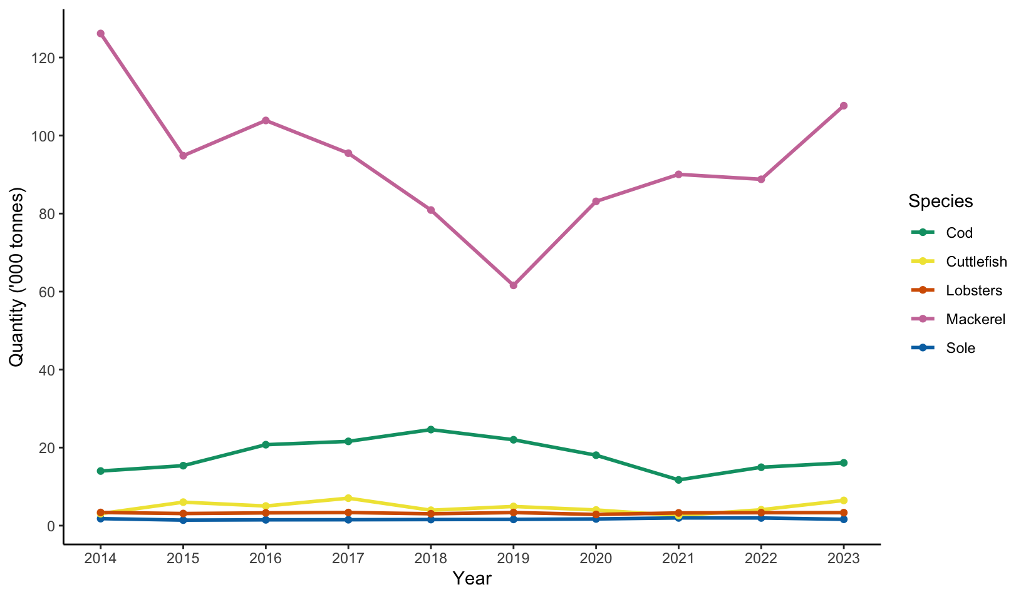

**Figure 2.** Quantity (tonnes) landed by species into the UK by UK vessels from 2014 -2023.

**Figure 3.** Total value (orange) and quantity (blue) of all species landed in the UK by UK vessels. The monetary value has been converted to prices in 2023 using the CPI.

Total landings in Scotland from UK vessels

**Figure 4**. Total catch (green) and value (yellow) of landings into Scotland by UK vessels from 2014- 2023. The value of landings has been converted to equivalent prices in 2023 using the CPI.

Scottish fleet

**Figure 5**. Size of the fleet under Scottish administration and vessel sizes from 2014 – 2023.

**Discussion**